Lab 13: Payroll
Please read the instructions carefully! The goal of this lab is to have you experiment with various combinations of functions, parameters and return values.
Lab 13a: no parameters, no return value: Write a procedure called payroll that takes no parameters and no return value. The procedure should be called by main() and payroll() should prompt the user for his/her hourly pay rate (a double) and the number of hours he/she worked (an integer). Display the information to the user.
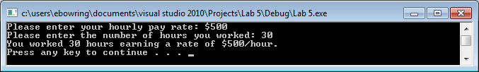
Lab 13b: 2 parameters, no return value: Write a function called calcPay that takes 2 parameters – the hourly rate and number of hours worked – but has no return value. The function should be called by payroll(). The function should calculate the user’s gross pay given its parameters: gross pay is equivalent to hours * rate. Display the information to the user.
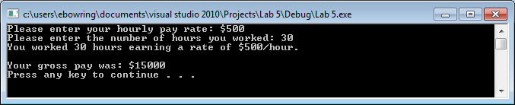
Lab 13c: 1 parameter, 1 return value: Write a function called taxRate that takes 1 parameters – the gross pay – and returns an integer between 0 and 100 representing the user’s tax rate. The function should be called by calcPay(). The function should use the following if-else to decide what the user’s tax rate is:
- If gross pay < $725, tax rate is 10%.
- Else if the gross pay is < $2945, then the tax rate is 15%
- Else if the gross pay is < $7135, then the tax rate is 25%
- Else if the gross pay is < $14887, then the tax rate is 28%
- Else if the gross pay is < $32362, then the tax rate is 33%
- Else the tax rate is 35%.
Lab 13d: Update the code in calcPay() to call taxRate() and then to subtract out the tax from the user’s gross pay, i.e.:
pay = grossPay - grossPay * (rateOfTax/100.0);

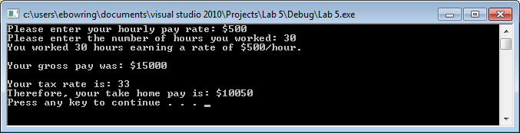

When you are done writing the program, write in the comments at the top of the code definitions for the terms: parameter and argument. Make sure everyone in the group can explain the difference between the terms parameter and argument.

